Supporting Stronger Communities
grant program

Guidelines for Partnership Arrangements

Enabling Neighbourhood and Community Houses and Centres to address poverty and disadvantage to strengthen their local communities.

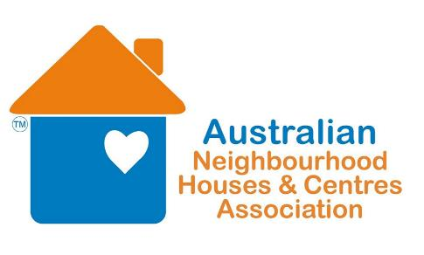
Supporting Stronger Communities grant program
Guidelines for Partnership Arrangements
Aim of grant program -
The Supporting Stronger Communities (SSC) grant program gives Neighbourhood and Community Houses and Centres the opportunity to access funds to target poverty and disadvantage in their local communities.
Other local Community groups and organisations are also able to apply by forming a partnership with their local Neighbourhood or Community House or Centre.
ELIGIBILITY -
If a Neighbourhood or Community House or Centre would like to apply with another community organisation, there are some basic criteria that will need to be met within the Partnership Arrangements.
These include –
- The Neighbourhood or Community House or Centre will take the lead role. This will involve being the main contact for the project / program. They will also take on the financial and legal responsibility for the duration of the project / program.
- There will need to be evidence provided in the application form outlining the partnership arrangements. This will include clearly defining the roles of both partners and their contribution to the project / program.
- There will need to be a letter of support provided by both the Neighbourhood or Community House or Centre and the Community Organisation outlining their commitment to the project / program.
If you are unsure whether your partnership arrangement will be eligible for funding, please call the ANHCA Grants Officer Emily Harnett on (03)9602 1228 or email emily@anhca,org

